INTRODUCTION

The subject of this overview is the Scenix V.23 modem reference design. Scenix Semiconductor, Inc., has completed a design for a V.23 modem, operating in originate mode, to suit the needs of some of its customers. This document is a brief overview of some of the functions performed by the V.23 modem, and the methods by which they are accomplished.

SERIAL COMMUNICATIONS
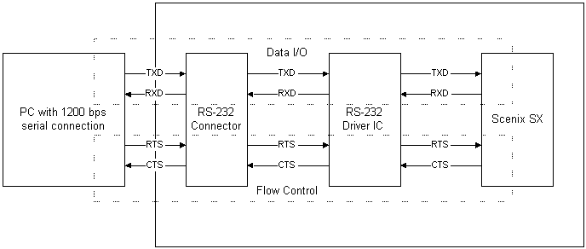
V.23 UART circuitry block diagram

Universal Asynchronous Receiver/Transmitter
- 1200 baud
- No Parity
- 8 Data Bits
- 1 Stop Bit
- Hardware Flow Control (CTS, RTS)

The UART is integrated into the Interrupt Service Routine of the software, which runs every 3.26us. The UART runs on every 16th pass of the ISR, or every 52.16 microseconds. The bit time for a 1200bps UART is 83.33 milliseconds. Dividing 83.33 milliseconds by 52.16us gives a result of 15.97, or 16, an easy divide ratio in any binary system.

Compact AT command set
- 64-byte command buffer
- Dial: “ATDTxxxxxxxxx…”
- Switch from data mode to command mode: “+++”
- Switch from command mode to data mode: “ATO”
- Hang up: “ATH”
- Initialize: “ATZ”
- Hybrid Optimization “ATY”

The AT-commands were chosen to provide enough functionality for a very simple modem design. Since the SX originate-only modem can only originate a data call, no answer functions are implemented. Incoming AT-commands are stored in a 64-byte buffer, and compared to software lookup tables on reception of a carriage return.

SIGNAL GENERATION AND DETECTION
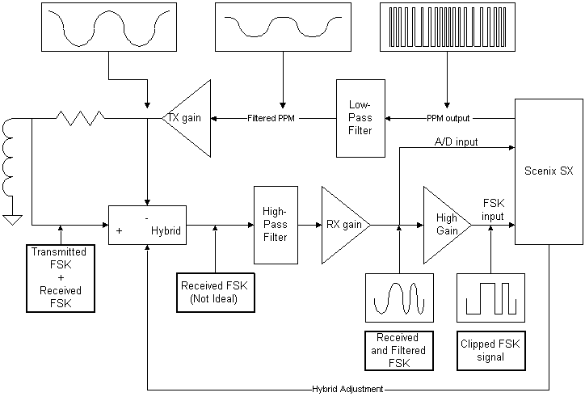
Signal Generation/Detection Block Diagram

Dual-Tone Multiple-Frequency Generation for Dialing
- Tones generated: 697Hz, 770Hz, 852Hz, 941Hz, 1209Hz, 1336Hz, 1477Hz,1633Hz,
± 0.5Hz
- On time = 100ms
- Off time = 100ms
- Off-hook delay time before dialing = 4 s
- D/A conversion provided by filtered PPM output

DTMF generation is performed completely by the software in the V.23 modem. For speed’s sake, a 32-byte lookup table is used to store each value of the sine wave. The frequency of each sine wave is set by a 16-bit value, giving a frequency resolution of [1/(3.26us * 2¹⁶ * 32)] = 0.15Hz.

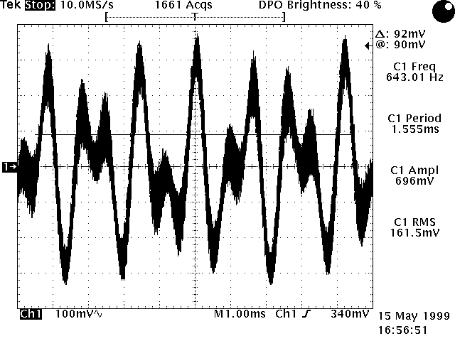
Filtered DTMF Output

Data transmission and modulation
- FSK transmission data rate at 75bps
- Hardware flow control, 16-byte buffer, and 75bps asynchronous transmitter for data rate conversion from 1200bps to 75bps
- Logic ‘1’ (mark) modulated by 390 Hz
- Logic ‘0’ (space) modulated by 450 Hz
- Transmission power = -15dB
- D/A conversion provided by filtered PPM output

Baud-rate conversion for converting the 1200bps stream from the PC to a 75bps transmit rate is accomplished via. a 16-byte buffer, hardware flow control, and a 75bps asynchronous transmitter. The modem fills transmits any bytes received from the PC until the 16-byte buffer is almost full, at which point it disables CTS, stopping the flow of data from the PC. It re-enables CTS when the buffer is full. The 75bps data modulates a carrier to 390Hz for a mark or 450Hz for a space. A 32-byte lookup table and a 16-bit frequency selection register generate the carrier, accomplishing a frequency resolution of 0.15Hz. The Pulse Position Modulator performs the D/A conversion.
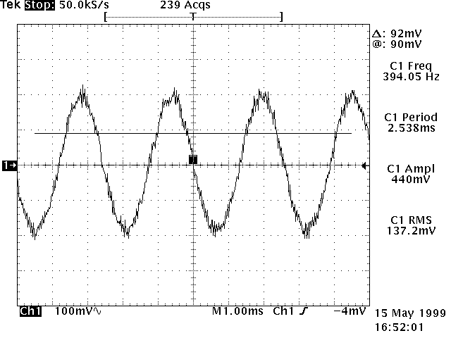
390 Hz FSK output into 600 ohm line impedance

Data reception and demodulation
- FSK reception data rate at 1200bps
- Logic ‘1’ (mark) demodulated from 1300Hz carrier
- Logic ‘0’ (space) demodulated from 2100Hz carrier
- Carrier detection
- Timed-Zero-Cross algorithm
- Carrier Detection

The FSK receive portion of the modem software is performed completely by the Interrupt Service Routine, with no logic required in the mainline routine. FSK receive is enabled via the fsk_rx_en flag in the global flags register. Once enabled, the FSK receive algorithm sets or clears the RS-232 transmit pin, depending on the incoming FSK signal. The algorithm used for receiving the FSK signal is a timed zero-cross. The FSK signal is converted to a square wave by the analog circuitry, and the time between transitions is compared to a threshold. Hysterises is used to reduce the impact of noise on the incoming FSK signal.
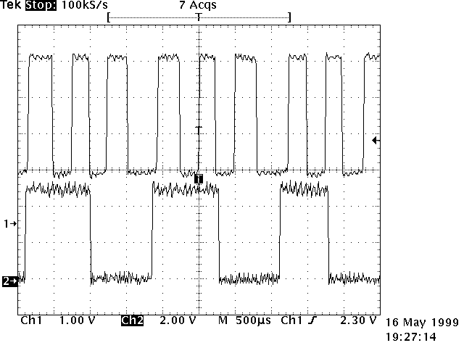
Demodulating the FSK square wave into data.
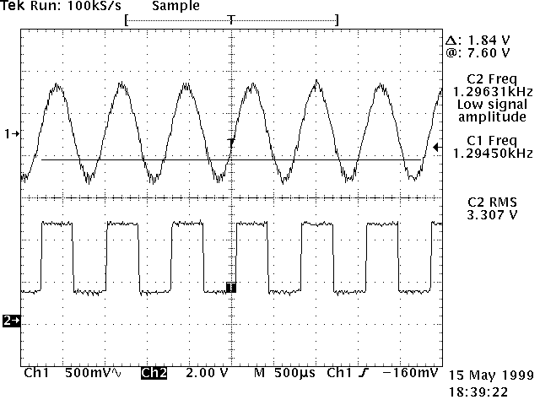
Converting the analog signal to a square wave for FSK demodulation

D/A conversion
- Pulse Position Modulation with maximum output frequency of 154kHz
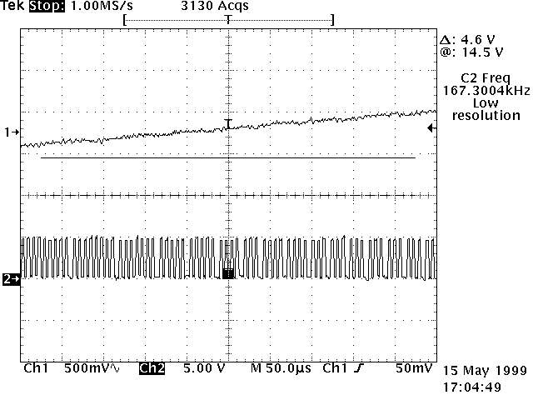
Top: Filtered PPM output
Bottom: PPM input
A simple Pulse Position Modulator is used to perform the Digital to Analog conversion. The resolution of the PPM modulator is 3.26 microseconds, resulting in a maximum output frequency of 154kHz. A low-pass filter with a cutoff of 1.6kHz or greater is used to filter the PPM signal.

Filtering
- Low pass filter on PPM output
- High pass filter on FSK input

All filtering is performed by external analog circuitry. The low-pass filter on the PPM output is a second-order filter with a cut-off frequency of ≅ 1.6kHz, and the high-pass filter on the FSK input is a fourth-order filter with a cut-off frequency of ≅ 1.2 kHz. There is a first order low-pass filter on the hybrid (input) with a cut-off frequency of ≅ 2.4kHz.

Hybrid
- Four settings provided for automatic hybrid adjustment for various line impedance’s
- Hybrid adjusted by outputting signal onto line and measuring fed-back signal with a low-resolution sigma-delta A/D converter

Because of the high attenuation at the filtering stages, it is not necessary for the hybrid to be perfectly matched to the line impedance. Four impedance-match settings are provided by the V.23 reference design. On initialization, the modem outputs a DTMF digit to quiet the line. It then outputs a 2100Hz tone to disable the line equalizers, and measures the amplitude of the signal being fed-back. Each setting is tried, and the setting that produces the most attenuated feedback is saved and used. This allows the SX reference design to be optimized in software for each individual telephone line. The command to optimize the hybrid is “ATY.” The optimization process takes about 10 seconds. Optimization needs to be performed each time the modem is powered down, since there is no NVRAM on the board to remember the result of the last optimization.

